Temple of Nur

Overview
Similar to ‘Wizardry’ in game sense, ‘Temple of Nur’ takes a spin on the traditional dungeon exploring genre by having you enter these secret dungeons alone instead of going as an entire party. With this, players will be forced to work around their selected classes' inherent weaknesses and incapabilities through various strategic and creative methods.
The objective of your character is to make it through the dungeon, avoiding obstacles and monsters along the way to reach the ‘Tome of Idris’. Your character's actual reason for attaining this ancient tome varies depending on your class and eventual grade.

Denomination System
Players will be given the option of selecting their character denominations when starting the game. These are split into the following:
- Mage - Mages represent the embodiment of magic and mana itself. They have spent their lives dedicating themselves to that craft and as such have a ranged centred build with high attack and low defence.
- Gish - Gishes represent the intersection between devout magical practice and adeptness in physical combat. While they are no strangers to the use of magic, their skilfulness with it greatly falters against that of mages. However, to make up for this they have armed themselves with the physical skills to take on enemies even without magic. Gishes combine the two to create a combat style that merges the best parts of both.
- Knight - Knights are sort of like Gishes in this aspect. Knights whilst technically making use of the two, still use them separately. They have a decent grasp of magic but not on the level of a mage or gish. Their physical capabilities and stats far exceed those of the two denominations, however. Maintaining their knightly virtue, they tend to limit themselves to only a few types of magic as the others are seen as unholy or unorthodox by the church.
- Barbarian - The most brutal of the denominations, barbarians pride themselves by their overwhelming strength and combat capabilities. Their environments have forged them into unyielding fighters, and they are constantly fighting in life-or-death situations out in the harsh clutches of nature. They have the highest strength and defense of the classes but have significantly lower knowledge and luck.

** Grades exist within these denominations; Represent lateral growth within your chosen denomination and allegiance. This is to say that multiple grades of the same skill level within the same denomination can exist

Statistics
This will act as the central backbone to which all combat within the game operates on. The game will have 5 primary statistics:
- Vitality - This is less of a stat and more of a general attribute that all characters regardless of denomination will share. This represents the amount of health that a character has and will incrementally increase depending on a character's level.
- Arcana - This is essentially the amount of mana that a character has. Any magic based attack they perform will consume mana and decrease the amount of arcana they have. (Barbarians Arcana bar will be permanently disabled)
- Attack - This is relatively simplistic, representing the amount of damage a character will do when attacking (without any status or weapon buffs).
- Intelligence - Scales magic-based attacks as well as attack consumption. Having high intelligence not only decreases your overall mana consumption but also reduces the chance of missing magic based attacks.
- Defense - There are two types of defenses. Magic defense and Physical defense. The base defense stat affects both, meaning that if my character has 50 defense then they have 50 magic defense and 50 physical defense respectively.
- Luck - Within the combat system of the game there exists a mechanic that lets players to miss their attack or fail to inflict status ailments onto enemies. This is largely determined by the player's luck. This will also be applied to non-combat areas of the game such as treasure acquisition or encounter rate.

Dungeon Mapping
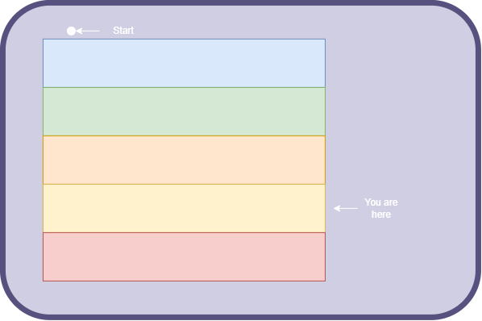
The mapping for the dungeon will work similar to the way it works for blasphemous. Players will be able to unlock teleportation gates the further along in the dungeon they travel and can essentially use that as a form of fast travelling. Players can open up the map, and this will display the areas they have already visited within the dungeon.
Essentially there will be a main map showing individual floors separately then the player can decide to look at the inner map of a layer.

Character Creation

